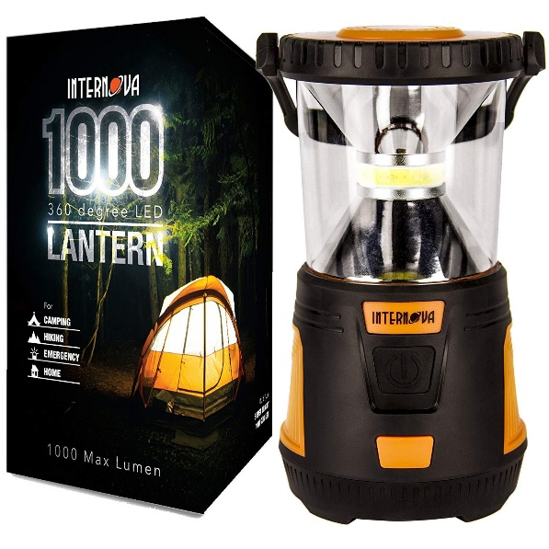
Internova 1000 LED Camping Lantern
Massive Brightness with Fully Adjustable 360 Arc Lighting – Emergency – Backpacking – Construction – Hiking – Auto – Home – College
$39.75

- Lightweight and portable design – weighs only 1.5 pounds
- Can be used indoors & outdoors – doesn’t make any noise
- Choose from 4 Modes: Low, High with Dimmer, Red, and Red SOS
- Includes a sturdy rubber handle to hang lantern
- Extra durable, water-resistant lantern that can be used in rain or snow
- Non-Slip base made from strong rubber & plastic
- Super bright 1000 maximum lumens output and 360 degree Arc lighting
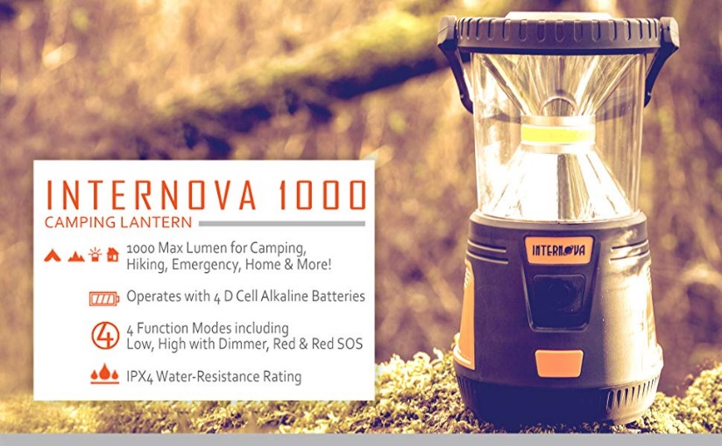

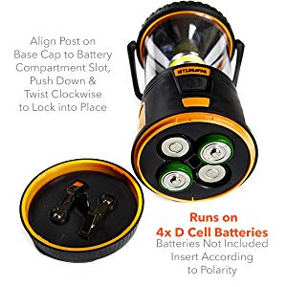
Product Details:
Dimensions: 5.5 x 5.5 x 9.8 inches; 1.5 pounds
Batteries: 4 D batteries required (not included)
Sturdy Rubber Handle
Water Resistant & Plastic Molded Base
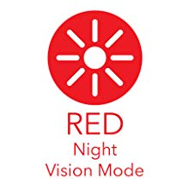
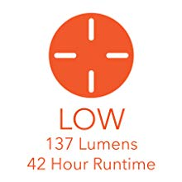
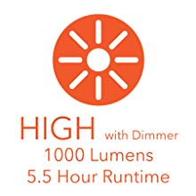
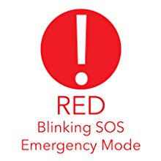
High with Dimmer Mode
Modes, Lumens and Run Times
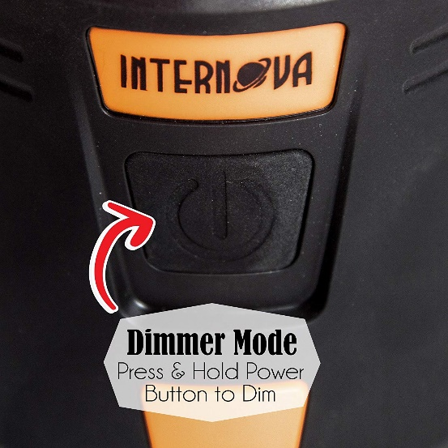

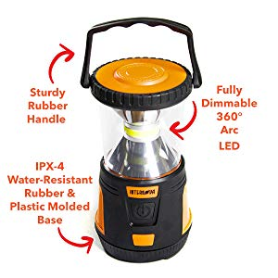

Additional Features:
- Massively bright or elegantly dim
- Incredible durability – built to weather the elements
- Designed for stability
- Five full hours of non-stop, cool-running, dependable safety in emergencies
- Choose between brilliant white for ultimate brightness, red LED’s for stargazing night, or the built in red SOS function to keep you and your family safe during an emergency

